Blanca Marquez

CST 336 - Henderson

February 6, 2019

Two “New” HTML tags

* <h2>
  + Defines the type of HTML heading which happens to be smaller than h1.
* <ol>
  + Defines an ordered list with default numerical points.

Two “New” CSS properties

* flex
  + Sets up the flex container. According to w3schools, “A shorthand property for the *flex-grow, flex-shrink*, and the *flex-basis* properties”.
* flex-direction
  + Sets up the main axis for the container. I chose to use column as opposed to row.

main.html

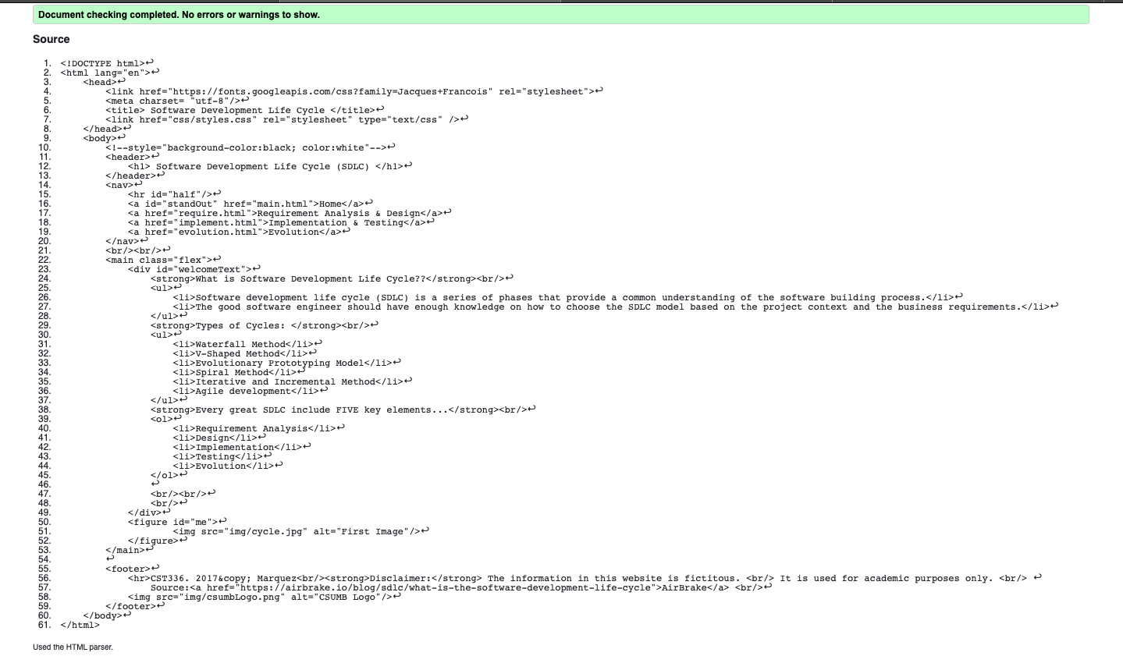

require.html

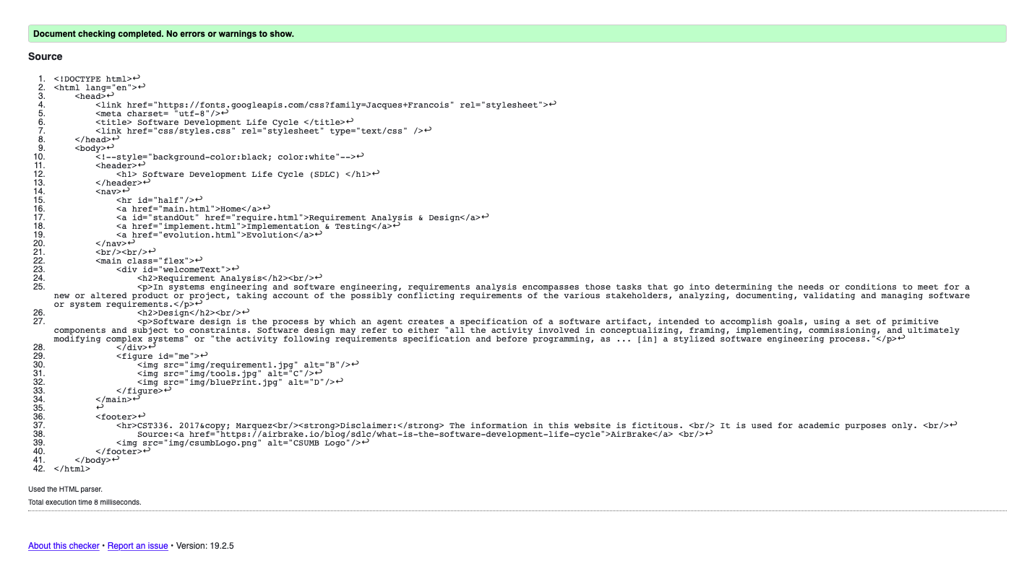

implement.html

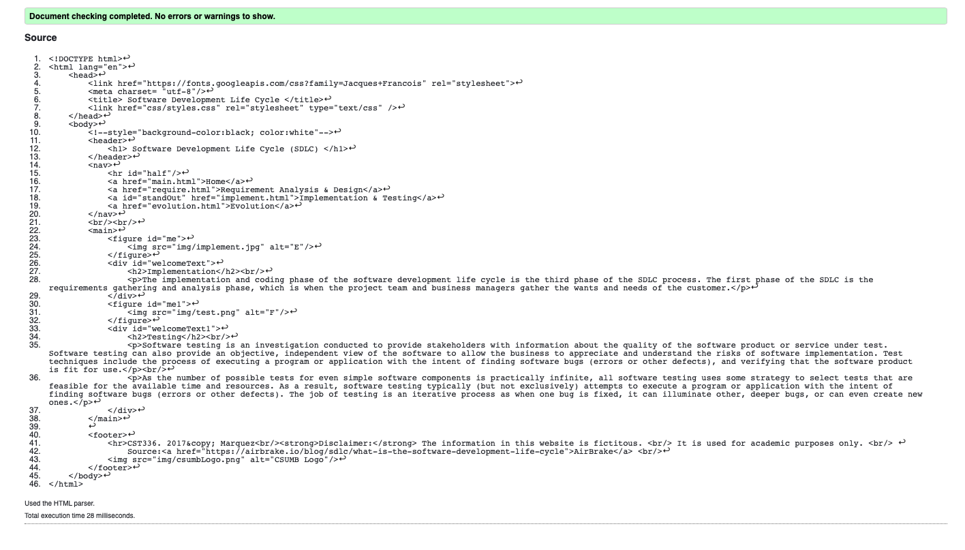

evolution.html

